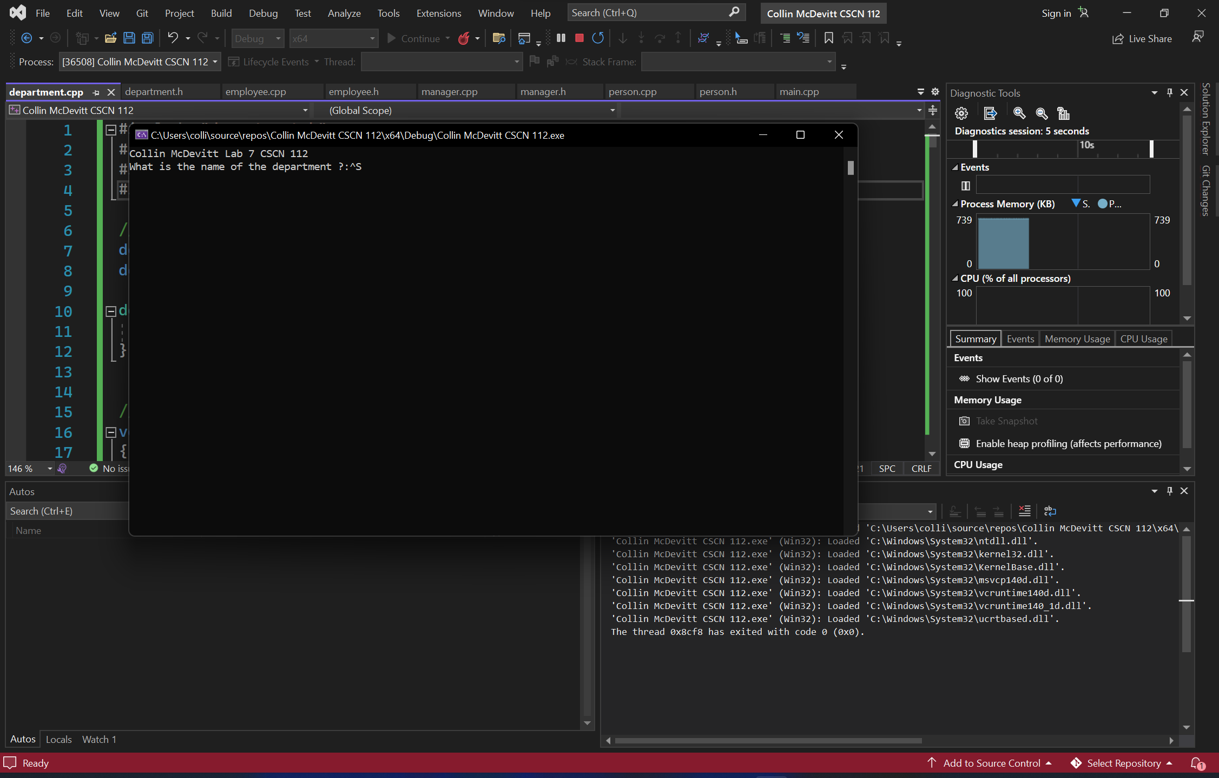

I have not shared the source code in my program with anyone other than my instructor’s approved human sources.

⦁ I have not used source code obtained from another student, or any other unauthorized source, either modified or unmodified.

⦁ If any source code or documentation used in my program was obtained from another source, such as a text book or course notes, that has been clearly noted with a proper citation in the comments of my program.

⦁ I have not knowingly designed this program in such a way as to defeat or interfere with the normal operation of any machine it is graded on or to produce apparently correct results when in fact it does not.

Algorithm

Main

Asks user for name of the store and asks for max number of employees and asks for expenses

Creates department object with constructor with the variables from above

Goes into loop that will ask for the user input and will use an if stament to decide the menu choice

If the user enters M then it will see if a manager already exists and has data in it if it doesn’t then it will call the functions that will ask for the input and will store it in the manager object

If the user enters E then it will check if the vector is already at the max number of employs if not then it will call the function that will ask for the data that will be stored in that employee it will then ask the user to enter a 1 or a 0 to if they enter a 1 it will ask for the job and store it in the jobs vector

If the user enters R then it will ask for the ID of the employ and will then see if that employee is actually in the vector if it is not it will tell the user that that employee isn't in the vector if it is in the vector then it will remove that employee

If the user enters L it will call the function that prints out the info for the department class this will print out all the info for the department and will only print a manager if it actually exists and will only print employee vector if it exits

If the user enters P then it will print out the manager name if there is one and will calculate the profit and expenses it uses and inline if else to see if the manager actually exits or not when subtracting his salary from the revenue then it will break out of the loop